eDC Gold Planned Receipting Guide

First thing in the morning (just once)
- Dock the PDA into cradle
- On the computer click on 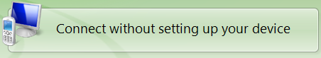
- On the PDA tap
- Tap

- After a period of time the screen will go green. Remove the PDA from the cradle
- Tap .
Now you are ready to receipt
- On the PDA tap

- Check delivery note order number and select using the drop down menu
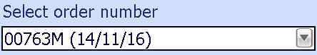
- Tap

- Scan primary barcode on item or type in the item reference number
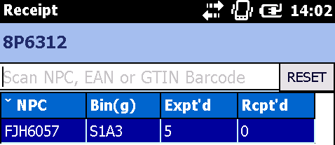
- Scan secondary barcode on each item to capture batch and expiry information
- Once all batch and expiry information is captured for that item. Tap

- Follow steps 4 and 5 until all items have been receipted on that order
- Check Expected vs. Receipted quantities match
- Tap

- You will receive prompt: “Are you sure you want to process all current receipting information for this store?”
- Tap

